1.1.6 Several forms of negation are given for each of the following statements. Which are correct?
- The carton is sealed or the milk is sour.
  - The milk is not sour or the carton is not sealed.
  - The carton is not sealed and also the milk is not sour. <-this one
  - If the carton is not sealed, then the milk will be sour.
- Flowers will bloom only if it rains.
  - The flowers will bloom but it will not rain.
  - The flowers will not bloom and it will not rain. <-this one
  - The flowers will not bloom or else it will not rain.
- If you build it, they will come.
  - If you build it, then they won’t come.
  - You don’t build it, but they do come.
  - You build it, but they don’t come. <-this one

1.1.10 Let A, B, and C, and D be the following statements:
A The villain is French.
B The hero is American.
C The heroine is British.
D The movie is good.
Translate the following compound statements into symbolic notation.
a. The hero is American and the movie is good. -> B^D
b. Athough the villain is French, the movie is good. D^A
c. If the movie is good, then either the hero is American or the heroine is British. -> D->[(B^C’)v(B’^C)]
d. The hero is not American, but the villain is French. -> B’^A
e. A British heroine is a necessary condition for the movie to be good D-> C

1.1.11 Use A, B, and C as defined to translate the following statements into English.
Definitions: A Roses are red. B Violets are blue. C Sugar is sweet.
a. B v C′ -> Violets are blue or sugar is sour.
b. B′ v (A -> C) Violets are not blue or, if Roses are red then sugar is sweet.
c. (C ^ A′) <-> B Sugar is sweet but Roses are not red is necessary and sufficient for violets are blue.
d. C ^ (A′ <-> B) Sugar is sweet but Roses are not red is necessary and sufficient for violets are blue.”
e. (B ^ C′)′ -> A If Sugar is sweet or Violets are not blue, then, roses are red.
f. A v (B ^ C′) Roses are red or violets are blue and sugar is sour
g. (A v B) ^ C′ Roses are red or violets are blue and sugar is sour

1.1.13 Using letters H, K, A for the component statements, translate the following compound statements into symbolic notation.
Definitions: H: horse is fresh, K: knight will win, A: armor is strong.
a. If the horse is fresh, then the knight will win. H->K
b. The knight will win only if the horse is fresh and the armor is strong. K->(H^A)
c. A fresh horse is a necessary condition for the knight to win. K->H
d. The knight will win if and only if the armor is strong. K<->A
e. A sufficient condition for the knight to win is that the armor is strong or the horse is fresh (AvH)->K

1.1.16 Using letters P, C, B, L for the component statements, translate the following compound statements into symbolic notation.
Definition: P: Project is finished soon, C: the client will be happy, B: The bills will be paid, L: Lights will go out.
a. If the project is finished soon, then the client will be happy and the bills will be paid. P->(C^B)
b. If the bills are not paid, then the lights will go out. B’->L
c. The project will be finished soon only if the lights do not go out. P->L’
d. If the bills are not paid and the lights go out, then the client will not be happy. (B’^L)->C’
e. The bills will be paid if and only if the project is finished soon, or else the lights go out. B<->PvL
f. The bills will be paid if and only if either the project is finished soon or the lights go out. B<->[(P^L’)v(P’^L)]

1.1.17 Construct truth tables for the following wffs. Note any tautologies or contradictions.
e. (A -> B) -> [(A v C) -> (B v C)]
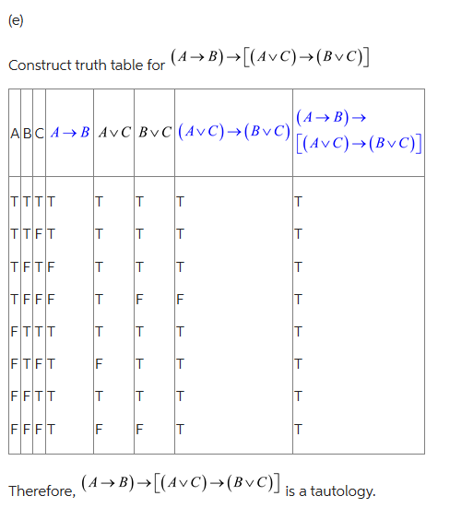
i. [(A v B) ^ C′] -> A′ v C

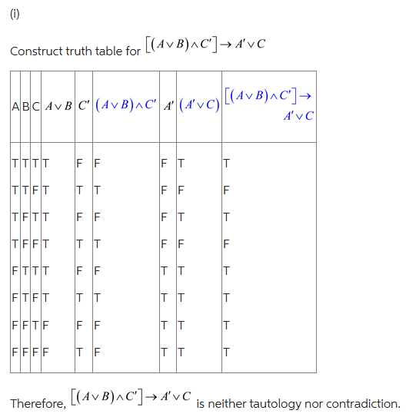

1.1.21 Prove the following tautologies by starting with the left side and finding a series of equivalent wffs that will convert the left side into the right side. You may use any of the equivalencies in the list on page 9 or the equivalencies from Exercise 26.
a. (A ^ B′)^ C <-> (A ^ C) ^ B′
(A ^ B′)^ C = A ^ (B′^ C) 1b
(A ^ B′)^ C = A ^ (C ^ B’) 1a
(three dot triangle) (A ^ B′)^ C <-> (A ^ C) ^ B’ 1b

b. (A v B) ^ (A v B′) <-> A
(A v B) ^ (A v B′) = A v (B ^ B’) 3a
(A v B) ^ (A v B′) = A v 0 5b
(three dot triangle) (A v B) ^ (A v B′) = A

c. A v (B ^ A′) <-> A v B
A v (B ^ A′) =(AvB)^(AvA’) 3a
A v (B ^ A′) =(AvB)^1 5a
(three dot triangle) A v (B ^ A′) =AvB 4b

d. (A ^ B′)′ v B <-> A′ v B
(A ^ B′)′ v B =(A’vB)vB demorgan
(A ^ B′)′ v B =A’v(BvB) 2a
(A ^ B′)′ v B = A’vB

e. A ^ (A ^ B′)′ <-> A ^ B
A ^ (A ^ B′)′ =A^(A’^B) demorgan
A ^ (A ^ B′)′ =(A^A’)v(A^B) 3b
A ^ (A ^ B′)′ =0v(A^B) 5b
A ^ (A ^ B′)′ =A^B 4a

Equivalencies:
